ALABAMA Regression

Median Income
Original series:
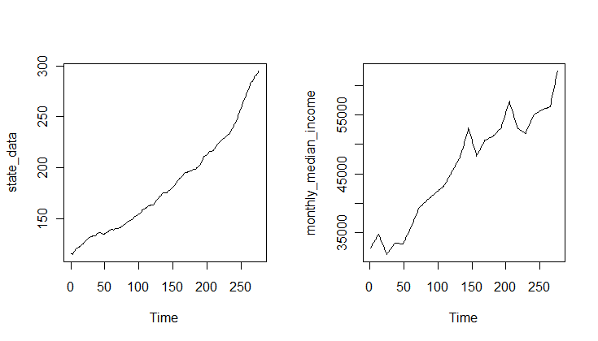

Call:
lm(formula = monthly_median_income ~ state_data)

Residuals:
Min 1Q Median 3Q Max
-6338.3 -2581.9 497.2 2860.4 7705.2

Coefficients:
Estimate Std. Error t value Pr(>|t|)
(Intercept) 15182.268 815.406 18.62 <2e-16 ***
state_data 167.707 4.297 39.03 <2e-16 ***
---
Signif. codes: 0 ‘***’ 0.001 ‘**’ 0.01 ‘*’ 0.05 ‘.’ 0.1 ‘ ’ 1

Residual standard error: 3387 on 274 degrees of freedom
Multiple R-squared: 0.8475, Adjusted R-squared: 0.847
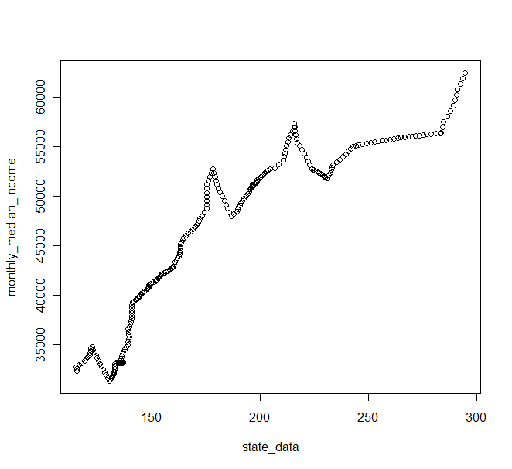
F-statistic: 1523 on 1 and 274 DF, p-value: < 2.2e-16

Simple returns:

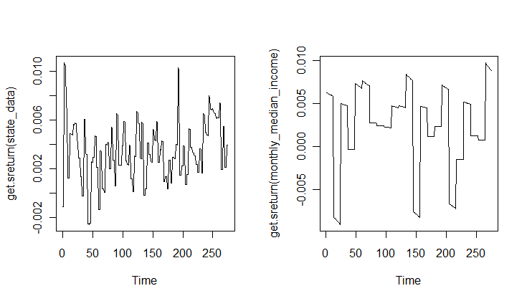

Call:
lm(formula = get.sreturn(monthly_median_income) ~ get.sreturn(state_data))

Residuals:
Min 1Q Median 3Q Max
-0.0112307 -0.0017369 0.0006926 0.0031574 0.0076022

Coefficients:
Estimate Std. Error t value Pr(>|t|)
(Intercept) 0.0032000 0.0004914 6.512 3.55e-10 ***
get.sreturn(state_data) -0.2328339 0.1167963 -1.994 0.0472 *
---
Signif. codes: 0 ‘***’ 0.001 ‘**’ 0.01 ‘*’ 0.05 ‘.’ 0.1 ‘ ’ 1

Residual standard error: 0.004763 on 273 degrees of freedom
Multiple R-squared: 0.01435, Adjusted R-squared: 0.01074
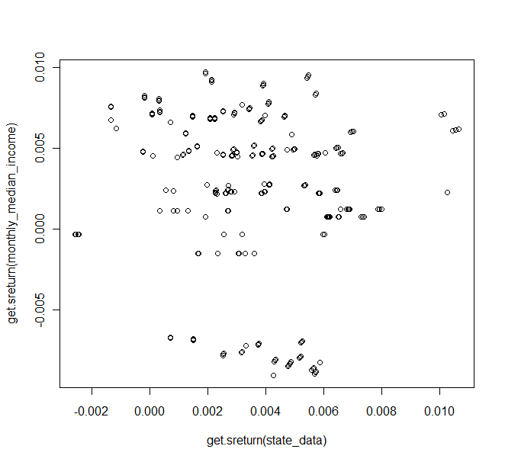
F-statistic: 3.974 on 1 and 273 DF, p-value: 0.0472

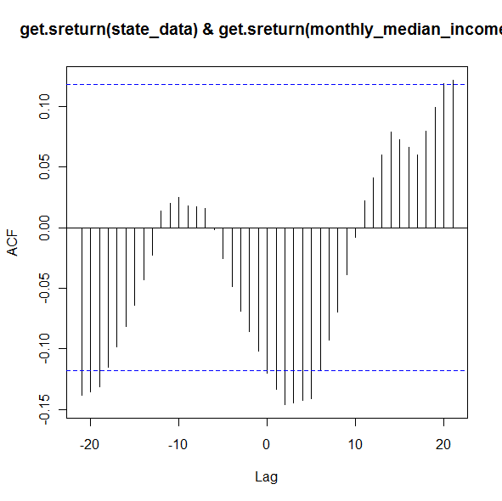

30 year current coupon
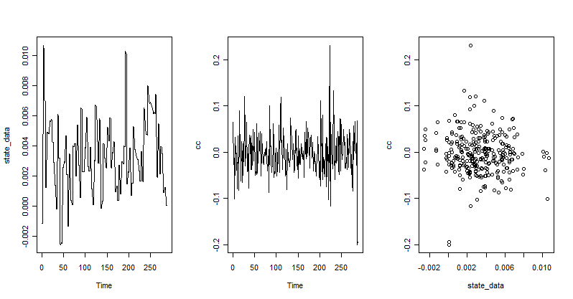

Call:
lm(formula = cc ~ state_data)

Residuals:
Min 1Q Median 3Q Max
-0.201428 -0.027724 -0.001911 0.024299 0.232707

Coefficients:
Estimate Std. Error t value Pr(>|t|)
(Intercept) 0.001640 0.004483 0.366 0.715
state_data -1.398559 1.083687 -1.291 0.198

Residual standard error: 0.04507 on 285 degrees of freedom
Multiple R-squared: 0.00581, Adjusted R-squared: 0.002322
F-statistic: 1.666 on 1 and 285 DF, p-value: 0.1979

30 year commitment rate

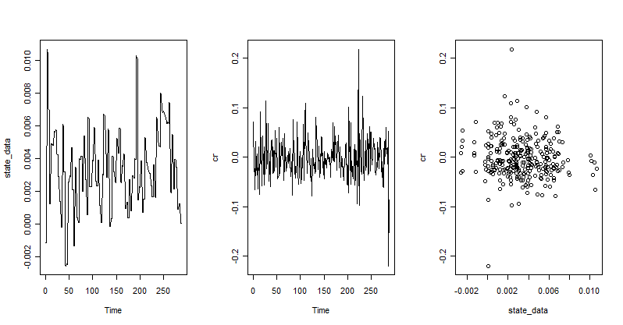

Call:
lm(formula = cr ~ state_data)

Residuals:
Min 1Q Median 3Q Max
-0.221776 -0.024161 -0.006191 0.021492 0.219494

Coefficients:
Estimate Std. Error t value Pr(>|t|)
(Intercept) 0.002044 0.004048 0.505 0.614
state_data -1.430934 0.978638 -1.462 0.145

Residual standard error: 0.0407 on 285 degrees of freedom
Multiple R-squared: 0.007446, Adjusted R-squared: 0.003963
F-statistic: 2.138 on 1 and 285 DF, p-value: 0.1448

Unemployment rate

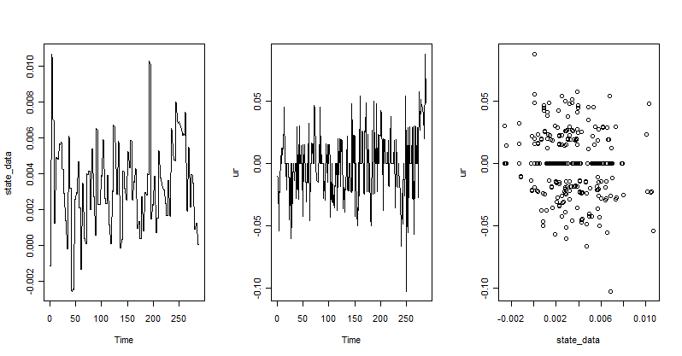

Call:
lm(formula = ur ~ state_data)

Residuals:
Min 1Q Median 3Q Max
-0.0955184 -0.0170770 -0.0001462 0.0165907 0.0829656

Coefficients:
Estimate Std. Error t value Pr(>|t|)
(Intercept) 0.004811 0.002549 1.887 0.06013 .
state_data -1.730003 0.616301 -2.807 0.00534 **
---
Signif. codes: 0 ‘***’ 0.001 ‘**’ 0.01 ‘*’ 0.05 ‘.’ 0.1 ‘ ’ 1

Residual standard error: 0.02563 on 285 degrees of freedom
Multiple R-squared: 0.0269, Adjusted R-squared: 0.02349
F-statistic: 7.88 on 1 and 285 DF, p-value: 0.005344

Population Size

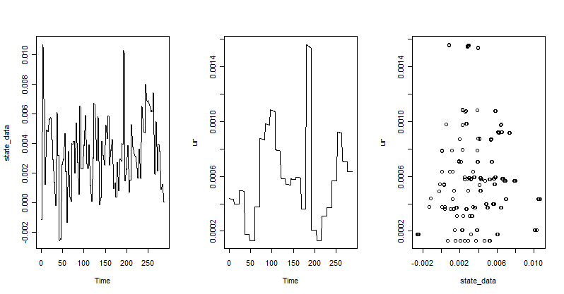

Residuals:
Min 1Q Median 3Q Max
-4.641e-04 -2.074e-04 -4.283e-05 1.793e-04 1.014e-03

Coefficients:
Estimate Std. Error t value Pr(>|t|)
(Intercept) 5.374e-04 3.261e-05 16.477 <2e-16 ***
state_data 1.115e-02 7.884e-03 1.414 0.158
---
Signif. codes: 0 ‘***’ 0.001 ‘**’ 0.01 ‘*’ 0.05 ‘.’ 0.1 ‘ ’ 1

Residual standard error: 0.0003279 on 285 degrees of freedom
Multiple R-squared: 0.006967, Adjusted R-squared: 0.003482
F-statistic: 1.999 on 1 and 285 DF, p-value: 0.1584

Median house median income

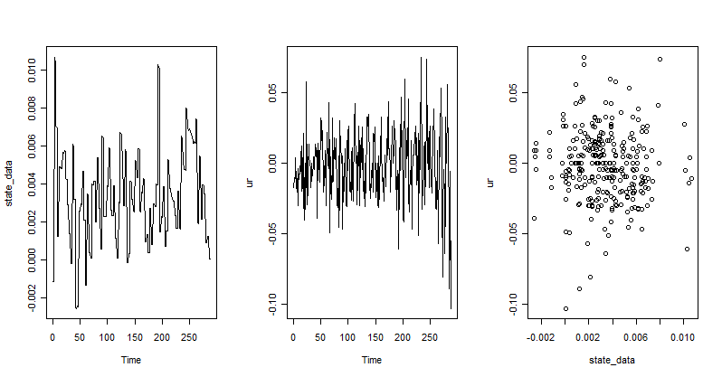

Residuals:
Min 1Q Median 3Q Max
-0.1028935 -0.0144153 0.0002554 0.0147532 0.0775475

Coefficients:
Estimate Std. Error t value Pr(>|t|)
(Intercept) 5.487e-05 2.476e-03 0.022 0.982
state_data -5.539e-01 5.985e-01 -0.926 0.355

Residual standard error: 0.02489 on 285 degrees of freedom
Multiple R-squared: 0.002997, Adjusted R-squared: -0.0005018
F-statistic: 0.8566 on 1 and 285 DF, p-value: 0.3555

Building permits

1/1995 – 12/2008

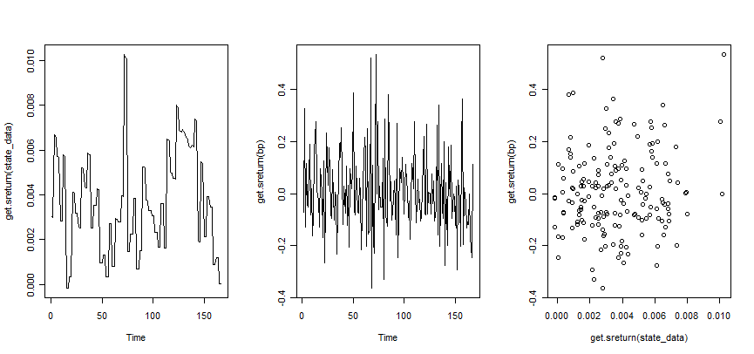

Call:
lm(formula = get.sreturn(bp) ~ get.sreturn(state_data))

Residuals:
Min 1Q Median 3Q Max
-0.36723 -0.10521 -0.01554 0.09262 0.52065

Coefficients:
Estimate Std. Error t value Pr(>|t|)
(Intercept) -0.01861 0.02333 -0.797 0.426
get.sreturn(state_data) 7.64245 5.46206 1.399 0.164

Residual standard error: 0.1593 on 165 degrees of freedom
Multiple R-squared: 0.01173, Adjusted R-squared: 0.005736
F-statistic: 1.958 on 1 and 165 DF, p-value: 0.1636

Population Growth

Change in population size so were are analyzing the simple returns of the pop size’ simple returns

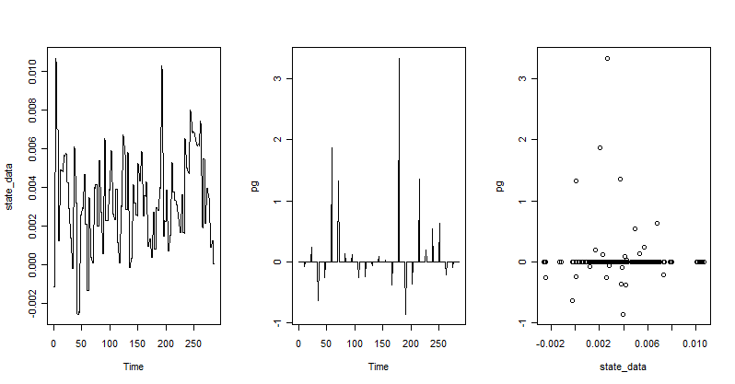

Residuals:
Min 1Q Median 3Q Max
-0.88511 -0.02401 -0.02232 -0.02023 3.32265

Coefficients:
Estimate Std. Error t value Pr(>|t|)
(Intercept) 0.02519 0.02697 0.934 0.351
state_data -1.03661 6.50859 -0.159 0.874

Residual standard error: 0.2698 on 284 degrees of freedom
Multiple R-squared: 8.931e-05, Adjusted R-squared: -0.003432
F-statistic: 0.02537 on 1 and 284 DF, p-value: 0.8736

Mortgage originations

Q1/1990 – Q4/2008

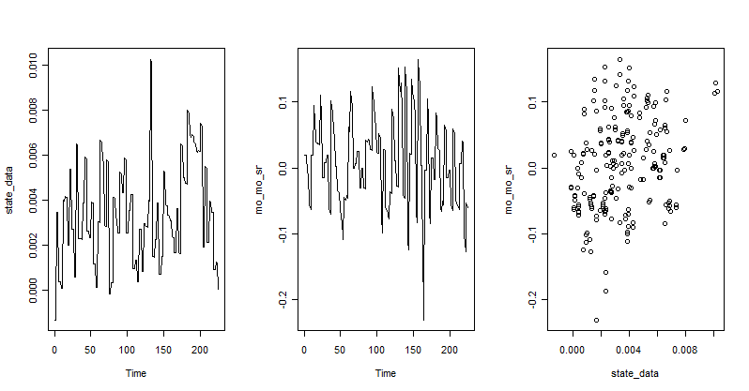

Call:
lm(formula = mo_mo_sr ~ state_data)

Residuals:
Min 1Q Median 3Q Max
-0.2232292 -0.0424532 -0.0007112 0.0417913 0.1589413

Coefficients:
Estimate Std. Error t value Pr(>|t|)
(Intercept) -0.020337 0.008013 -2.538 0.0118 *
state_data 7.981118 1.975134 4.041 7.33e-05 ***
---
Signif. codes: 0 ‘***’ 0.001 ‘**’ 0.01 ‘*’ 0.05 ‘.’ 0.1 ‘ ’ 1

Residual standard error: 0.06539 on 223 degrees of freedom
Multiple R-squared: 0.06822, Adjusted R-squared: 0.06405
F-statistic: 16.33 on 1 and 223 DF, p-value: 7.333e-05

Primary Interest Rate

Note: Used only 1/1999 – 12/2008 even though have data from 6/1998 – 2/2009

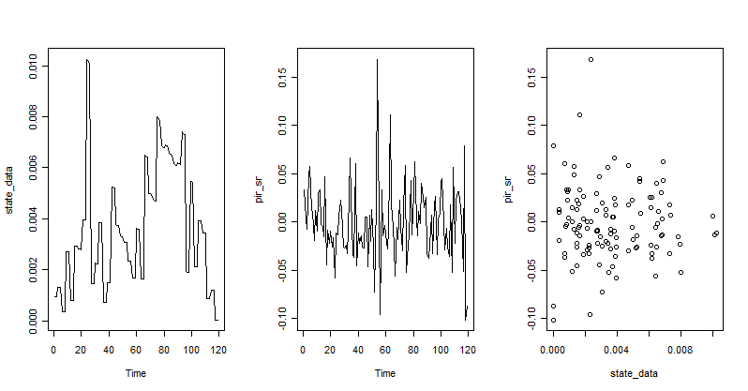

lm(formula = pir_sr ~ state_data)

Residuals:
Min 1Q Median 3Q Max
-0.102412 -0.024035 -0.005105 0.021025 0.169051

Coefficients:
Estimate Std. Error t value Pr(>|t|)
(Intercept) 0.001028 0.006367 0.161 0.872
state_data -0.619051 1.472298 -0.420 0.675

Residual standard error: 0.03834 on 117 degrees of freedom
Multiple R-squared: 0.001509, Adjusted R-squared: -0.007025
F-statistic: 0.1768 on 1 and 117 DF, p-value: 0.6749

